Deimos King Swing Harnesses
Zip Standard | Price (qty 1-24) USD
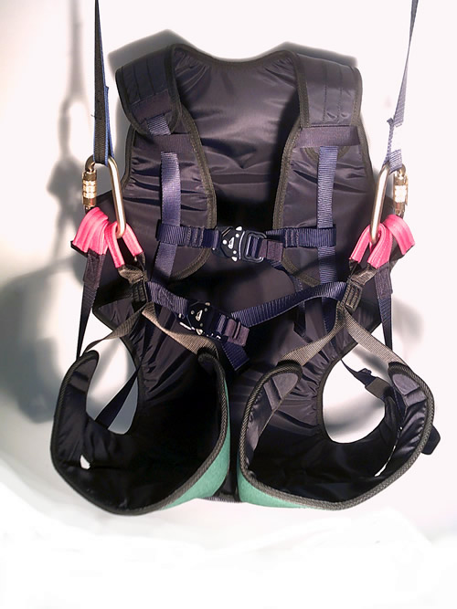  Certified EN 1651 | XS (40-80 lbs) - $330  S (80 - 170 lbs) - $332  L (160 - 210 lbs) - $334  XL (up to 265 lbs) - $364  XXL (up to 300 lbs) - Same as XL but with larger legs - $399  *Steel triple lock Carabiners order separately  Optional:  Small or large rear pocket (large pocket shown)  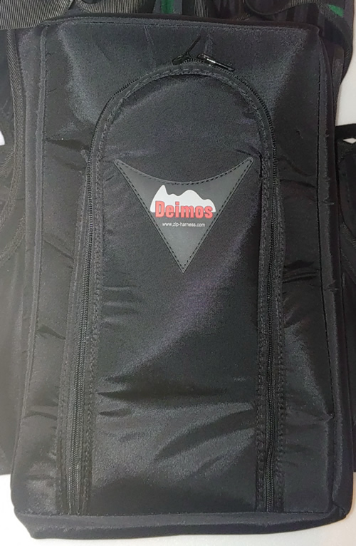

Zip Elevation | Price (qty 1-24) USD
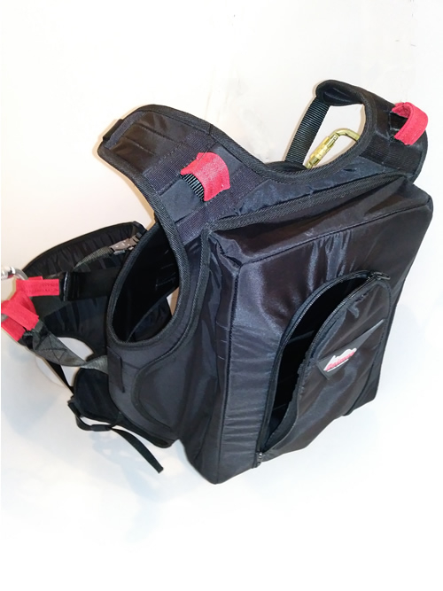  Certified EN 1651  Has (red) shoulder back-up loops | XS (40-80 lbs) - $350  S (80 - 170 lbs) - $352  L (160 - 210 lbs) - $354  XL (up to 265 lbs) - $414  XXL (up to 300 lbs) - Same as XL but with larger legs - $419  *Steel triple lock Carabiners order separately  Optional:  Small or large rear pocket - Small or large rear pocket (large pocket shown)

FreeStyle CZ | Price (qty 1-24) USD
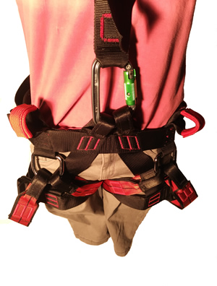  Certified EN 361, 813, 1651 | S (80-120 lbs) - $295  M (100-230 lbs) - $298  L (220-300 lbs) - $300  *Steel triple lock carabiners order separately  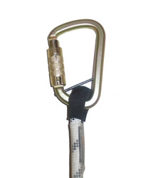

WallTee2 | Price (qty 1-24) USD
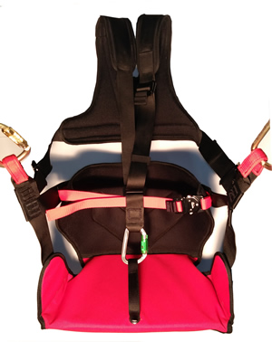  Certified EN 1651, 12277 | XS-S (55-132 lbs) - $426  M (66-195 lbs) - $428  L (190-260 lbs) - $455  *Steel triple lock carabiners order separately  **Includes wood seat board

